**TECNOLOGIA EN SEGURIDAD Y SALUD EN EL TRABAJO**

**DOCENTE**

**LILIANA HERNANDEZ AMADO**

**INGLES BASICO**

**JENNIFER NATALY APONTE PRADA**

**C.C. 1098697643**

**CONSOLIDADO DE LA UNIDAD 1**

**FUNDACION UNIVERSITARIA SAN MATEO**

**BOGOTA**

**2019**

**ACTIVIDAD 1**

**ACTIVITY 1**

**QUESTIONS**

1. Where does peter want to go?
2. According to Ramon how many town squares are there in town?
3. What is there in the town squares?

**ANSWERS**

1. Peter wants to visit El Museo de la Papa.
2. Ramon says they are two town squares.
3. In one of them there is a markertplace and in the other one, there is a monument to fallen soldiers of the process of Independence.

Link audio: <https://www.driveplayer.com/#fileIds=1slz53XMy7x2lBOSF9MNynDtXJRnLEMe0&userId=111051211511738976221>

**ACTIVIDAD 2**

**ACTIVITY 2**

**FOLLETO DE SANFRANCISQUITO**

**SAN FRANCISQUITO BROCHURE**

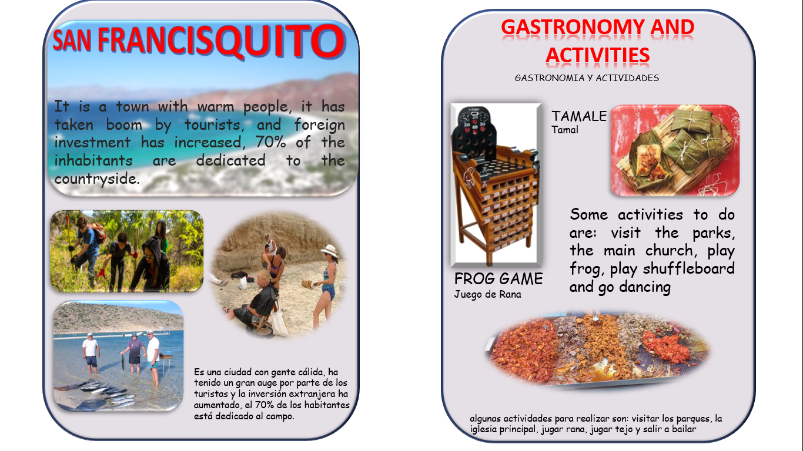

**ACTIVIDAD 3**

**ACTIVITY 3**

**CALL CENTER DE SANFRANCISQUITO**

**CALL CENTER OF SANFRANCISQUITO**

Link blog: <https://smalltipsen.blogspot.com/2019/03/san-francisquito.html>

Link audio: <https://www.driveplayer.com/#fileIds=1H04p-aV8hSR_Kc5TPmTpeJR9CyPakA8t&userId=111051211511738976221>

**ACTIVIDAD 4**

**ACTIVITY 4**

**CONSOLIDADO UNIDAD 1**

**CONSOLIDATED UNIT 1**

Link blog: <https://smalltipsen.blogspot.com/2019/03/unit-1-collection.html>